| **Job Sheet** |
| --- |

| **Module** | **:** | IoT Fundamentals | **Module Code** | **:** | EC33105FP | |
| --- | --- | --- | --- | --- | --- | --- |
|  |  |  |  |  |  | |
| **Job No** | **:** | 4 | **Duration** | **:** | F/T: | 2 hours |
|  |  |  |  |  | P/T: |  |

| **Job Title** | **:** | Interface Sensor - DHT11 |
| --- | --- | --- |
|  |  |  |
| **Objectives** | **:** | 1. Prepare RPi and Upswift 2. Connect DHT11 to RPi Pins 3. Execute program to get Temperature and Humidity |

**Tools, Equipment and Materials**

| PC |
| --- |
| RPi with microSD |
| RPi Power Adaptor  DHT11 x 1  Breadboard  4G WiFi Router |
|  |

**Number of Tasks to Complete**: 5

**Part A: Prepare RPi and Upswift (0.5 hour)**

Before performing any hardware configurations, we need to ensure that the RPi is accessible remotely.

YOU MUST HAVE COMPLETED JOB 1 BEFORE DOING THIS

**Task 1 – Prepare RPi and UpSwift**

Perform the following steps to setup RPi:

1. Connect only the power adaptor to RPi.
2. Turn on the power
3. Go to <https://dashboard.upswift.io/dashboard/> and login. The device would be **offline**.

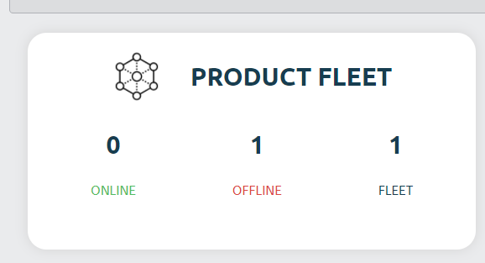

1. Wait for a while and refresh the web page by clicking . Device should appear online after 1 - 2 mins.



1. On the left side of your menu, click on the **Control** option under Control center.



1. On the page center, select your device and click open session.

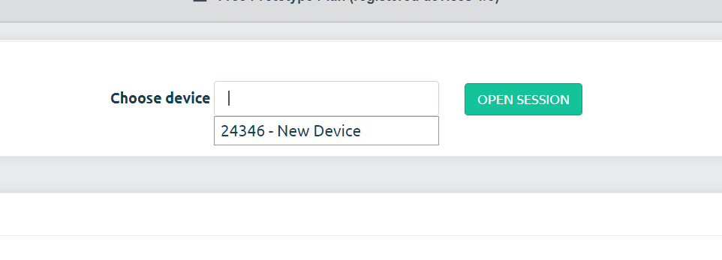

1. For the prompt, click **Open Remote Control.**

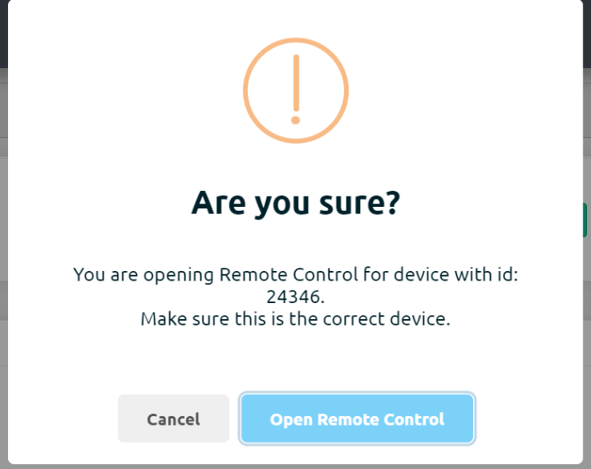

1. You will be shown a secret key. Click on **Copy to clipboard** button

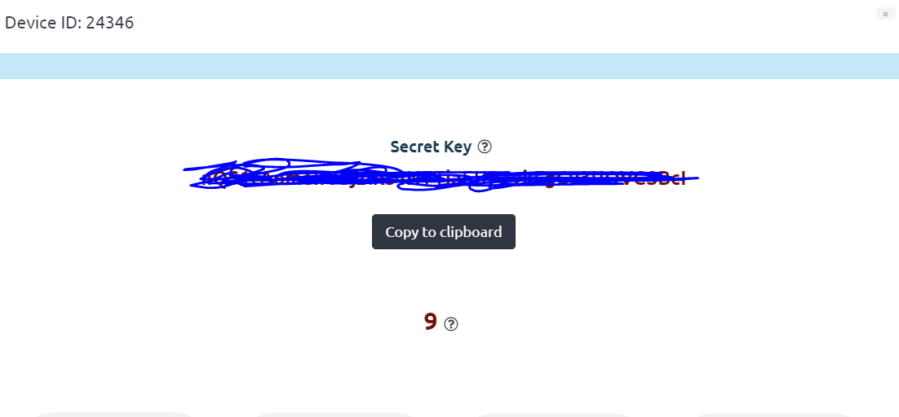

1. Once the timer is up, click on the **Open Remote Control** button.



1. **Paste** the secret key in the input text box and change username to pi. Click on **Connect**.

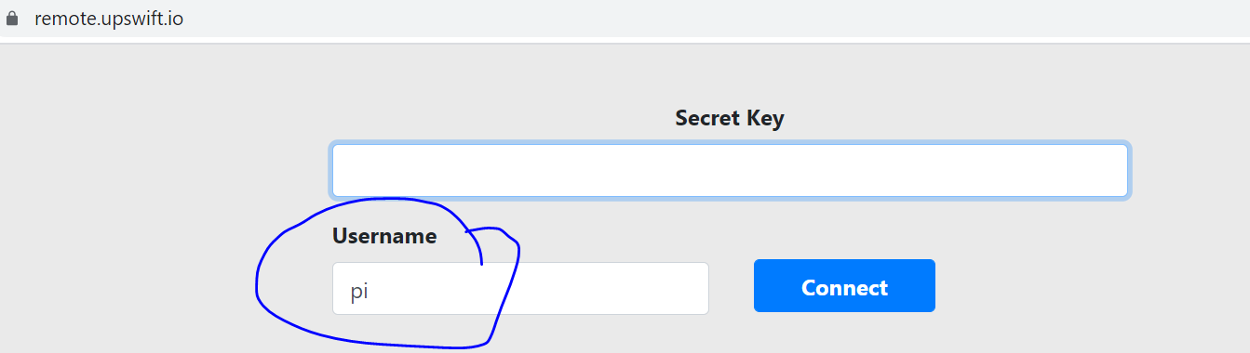

1. You will be presented with a browser based RPi terminal.

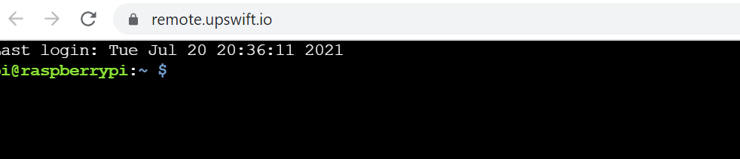

**Part B: Connect DHT11 to RPi Pins**

DHT11 **Temperature** & **Humidity** Sensor features a temperature & humidity sensor

complex with a **calibrated digital signal output.** By using the exclusive digital-signal-acquisition technique and temperature & humidity sensing technology, it ensures high reliability and excellent long-term stability. This sensor includes a **resistive-type humidity measurement** component and an **NTC temperature measurement component.**

The datasheet can be found here:

<https://www.mouser.com/datasheet/2/758/DHT11-Technical-Data-Sheet-Translated-Version-1143054.pdf>

The DHT11 has 3 pins, Vcc, Data and GND.

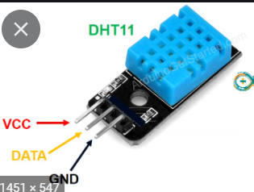

**Task 2 – Connect DHT11 to RPi**

Perform the following steps

1. Connect GPIO extension board from RPi to breadboard.
2. Connect DHT11 to the RPI using the breadboard as shown

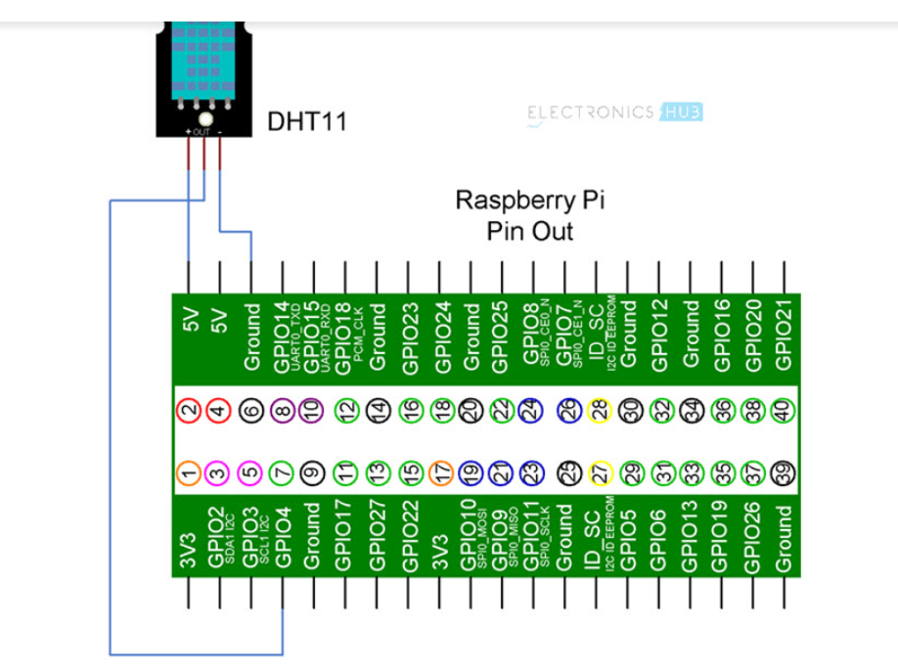

**Part C: Execute program to get Temperature and Humidity**

DHT11 uses a single bus data format for communication. Only a single data line between an MCU like Arduino or Raspberry Pi and the DHT11 Sensor is sufficient for exchange of information.

The implementation of this code is quite complicated for us at this stage, thus we will be using a library from Adafruit to assist us in getting the temperature and humidity.

**Task 3 – Install Adafrut DHT11 library**

1. Follow task one to open a remote terminal as shown.



1. Run **sudo pip3 install adafruit-circuitpython-dht**.
2. Run **sudo python3 -m pip install --force-reinstall adafruit-blinka**
3. The library should have been installed successfully.

**Task 4 – Execute program to get Temperature and Humidity**

Perform the following steps

1. Run **sudo nano job5.py.**
2. Copy the code found at <https://github.com/Prakashash18/iot-fundamentals/blob/main/job5.py>
3. Paste it into the nano editor by right clicking and pasting.

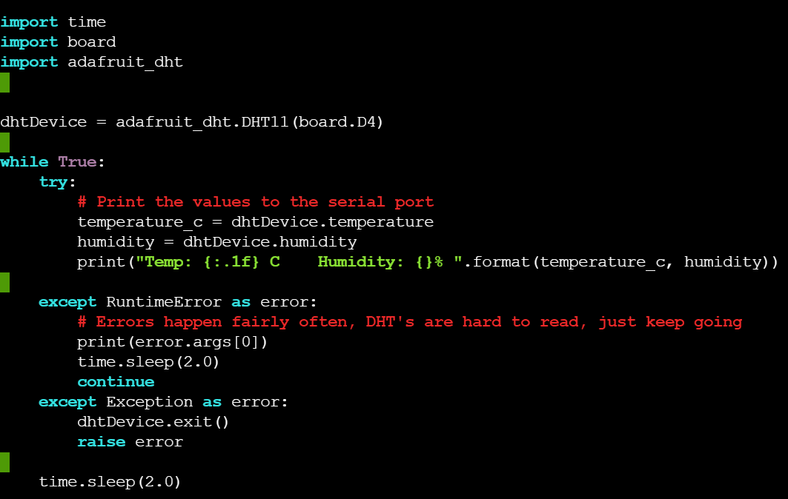

1. [Keyboard] Press CTRL + X to save your work. You will be prompted with the following message.

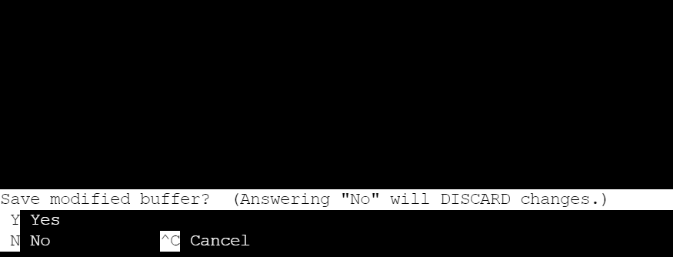

1. [Keyboard] Press **y** for yes and hit **Enter**
2. On the terminal, run **sudo python3 job5.py** to execute the code. Note that we are using python version 3.
3. You should see the temperature and humidity readings.

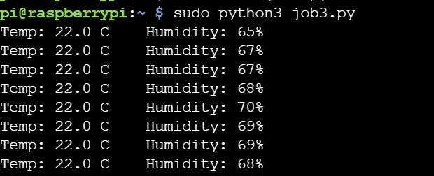

1. To stop the code on the terminal, press CTRL and C.

**Task 5 – Work Challenge**

You are working at ABC IoT Pte Ltd as a technician. You are part of the team monitoring the temperature and humidity at an industrial site. The current system only provides temperature with 1 decimal place accuracy.

You are asked to **edit the program in task 4 such that the temperature is shown with 2 decimal point precision. Example below.**

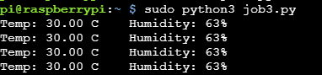

Show your working solution to your supervisor/lecturer.

**\*\*Hint, the only change is required in the print statement**

**Questions**

Refer to DHT11’s datasheet online for these questions.

The datasheet can be found here:

<https://www.mouser.com/datasheet/2/758/DHT11-Technical-Data-Sheet-Translated-Version-1143054.pdf>

1. What is the temperature accuracy of the DHT11 ?



1. What is the humidity accuracy of the DHT11 ?



1. What is the max voltage of the DHT11 ?



1. Can the DHT11 be used to measure the human body temperature? Write down yes or no and your reason as well.

